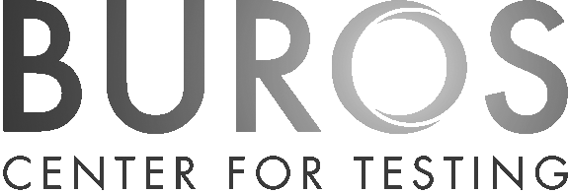

Associate Director of Psychometric Consulting
Research Assistant/Associate/Full Professor
Buros Center for Testing
College of Education and Human Sciences
University of Nebraska-Lincoln
The Psychometric Consulting unit is the contract research and outreach arm of the Buros Center for Testing. Its mission is to promote high quality tests and testing practices. Psychometric Consulting typically works with organizations that produce tests that are not commercially available. Clients include school systems (both local and state), other government entities, licensing agencies, certifying organizations, and private industry, both the testing industry and those industries that use educational, psychological, credentialing, or employment tests. The Buros Center has several units and operations, all of which work together smoothly. For more information about the Buros Center for Testing, visit our website at http://buros.org/psychometric-consulting. Candidates wishing more information are encouraged to contact Dr. Kurt Geisinger, Director of the Buros Center for Testing, kgeisinger2@unl.edu.
Duties and Responsibilities: The Buros Center for Testing is seeking qualified applicants for a 12-month professional position located in Lincoln, Nebraska. Responsibilities include: 1) administering ongoing contract/grant activities, initiating contract/grant activities, and participating in contract/grant activities initiated by others in the Center; 2) working with clients on continuing multi-year projects, writing contract/grant proposals, leading the planning team for developing new contracts/grants, designing research studies within the context of contract/grant activities; 3) designing and conducting workshops on measurement topics; and 4) making presentations to clients and at regional and national conferences.
The successful candidate will be expected to conduct an ongoing research program related to contract/grant activities and the publication of scholarly research. This position will also monitor the work of associated staff in the unit. This job entails travel dependent upon project demands.
Qualifications: Earned doctorate in Measurement, Psychology, Educational Psychology, Professional Psychology (e.g. school, counseling), I/O Psychology, or a related field. Substantial experience in conducting contracts/grants activity is required, primarily in educational testing and measurement or licensure and certification testing. A minimum of eight (8) years postdoctoral work in this area is required, with a strong preference for 10 years. Knowledge of program accreditation, high stakes testing programs, standard setting, aligning tests with content standards, test validation, and related technical issues in measurement is required. Excellent communication skills (both verbal and written) are essential. Experience in K-12 or higher education testing work preferred.
How to apply: To be considered for this position, please go to http://employment.unl.edu/postings/65431. Click on “Apply for this job,” complete the information form, and attach the following documents: 1) cover letter of application, 2) current curriculum vitae, 3) statement of research program with up to three PDF reprints of published papers (attach as “Other Document”), and 4) contact information for three professional references.
Review of applications will begin June 30, 2020 and will continue until the position is filled or the search is closed.
As an EO/AA employer, qualified applicants are considered for employment without regard to race, color, ethnicity, national origin, sex, pregnancy, sexual orientation, gender identity, religion, disability, age, genetic information, veteran status, marital status, and/or political affiliation. See http://www.unl.edu/equity/notice-nondiscrimination.

